Chapter 8, Problem 51.

Find v(t) for t > 0 in the circuit in Fig. 8.98.

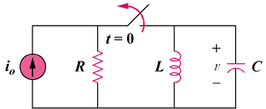

Figure 8.98
For Prob. 8.51.

